Northern University Bangladesh



**Lab report:** 03

**Department:** CSE

**Course title:** Digital Electronics & Pulse Technique Lab Work

**Experiment no:** CSE 2366

**Experiment name:** Implement Diode Transisitor Logic NAND, NOT gate in Tinkercad

**Submitted by** **Submitted to**

Name of teacher: Nizia Nahyan

Designation: Lecturer

Signature:

Name: Fardeen Ahmed

Id: 41210301615

Date of Experiment: 24/6/2024

Date of submission: 27/6/2024

DTL NOT gate

Circuit diagram:

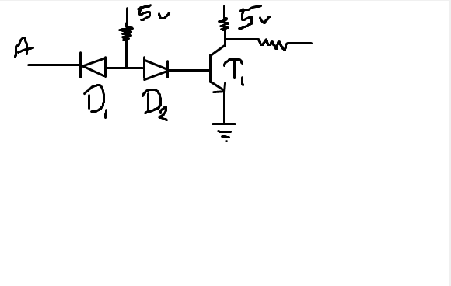

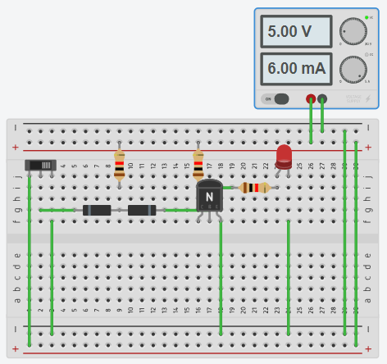Circuits Screenshot:

Tinkercad circuit link:

<https://www.tinkercad.com/things/j18QCBHvfxn-dtl-not-1615?sharecode=j0aKIWa8BDgBoqRqRjo8If8NFMnB1YD0Euz2IBJMHyI>

DTL NAND gate

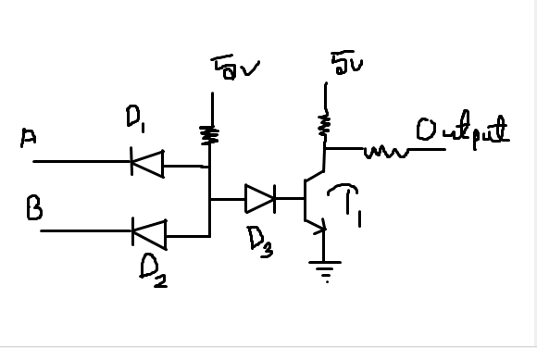Circuit diagram:

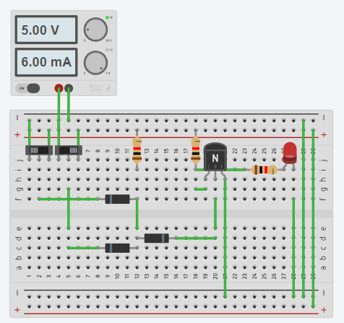Circuit screenshot:

Tinkercad circuit link:

<https://www.tinkercad.com/things/ixPrXUCA9qO-dtl-nand-1615?sharecode=Sgk8z7S9lLWINmn8ll00aGny9gtPwRpHp1wH3msOq-I>